Value Proposition

SANEDI

Plasma Gasification Waste Treatment (PlasWen)
By: Dr. IJ van der Walt and Dr NJ Smith Date: 2022-02-22

- INTRODUCTION
With plasma gasification, an electric arc heats a gas stream (air or nitrogen), at extremely elevated temperatures typically 5000⁰C, thereby supplying the required energy to the process.
The plasma delivers energy needed to maintain the temperature inside the gasification reactor volume at values needed for dissociation of molecules of gases produced by material decomposition. Due to the elevated temperature the ash, metals and glass in the waste are melted, organic components are volatilized, and complex molecules are dissociated. Molten slag is removed from the reactor, and after cooling and solidification, a substance similar to lava is produced. Organic materials, containing mostly chemically bound carbon, hydrogen, and oxygen, are decomposed into syngas that can be utilised as various energy products, for example high quality fuel or electricity. Figure 1 is an illustration of the gasification process.
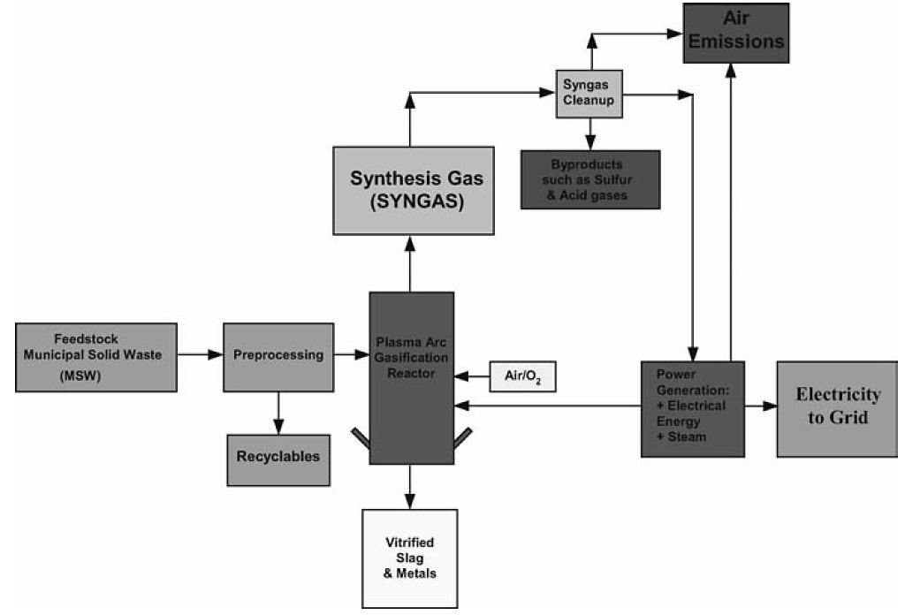
Figure 1: Typical Gasification Process
- TECHNOLOGY VALUE PROPOSITION
SANEDI commissioned NECSA to design and build a more environmentally friendly Plasma Waste Gasification (PlasGas) and Plasma Waste to Energy (PlasWen) systems. In plasma gasification a gas stream, typically air or nitrogen, is heated by an electric arc to extremely elevated temperatures (5000 °C or more) to supply the required energy to the process. Current systems are designed to meet varying, site-specific user requirements, which range from technology demonstration units and vitrification of municipal solid waste (MSW) incinerator bottom ash to the production of syngas for electricity generation. Compared to non-plasma methods the advantages of plasma waste treatment can be summarized as follows:
- The energy for gasification is supplied by plasma rather than energy released from combustion and is therefore independent of substances used, to provide flexibility, fast control over the process, and more options in the chemistry of the process. A broad range of waste feedstock can be used for gasification.
- No combustion gases are produced typically generated in conventional autothermal reactors).
- The temperature in the reactor can be easily regulated by controlling plasma power and the material feed rate.
- As sufficiently high temperatures and homogeneous temperature distribution can be easily maintained in the entire reactor, production of higher hydrocarbons, tars, and other complex molecules are substantially reduced.
- High energy density and high heat transfer efficiency can be achieved, by allowing shorter residence times and increased throughput.
- Highly reactive environment and easy control of the composition of reaction products.
- Low thermal inertia and easy feedback control.
- Much lower plasma gas input is required per a heating power unit than in non-plasma reactors, and therefore energy necessary to heat the plasma to reaction temperature is low; also, the number of gases diluting the syngas produced is lower.
- High energy densities, lower gas flows, and volume reduction enable use of plants that are smaller in size than non-plasma reactors.

- VALUE CHARACTERISTICS
The waste treatment product in question is a small scale (up to fifteen tons per day (tpd)) PlasGas or PlasWen, which uses waste as feed material to produce syngas that is capable to be converted into energy products such as electricity, fuel, hydrogen, heat or steam, etc. If electricity is generated, this can be used as auxiliary power to sustain the plant. In addition, the system will have spare capacity of electricity, to use elsewhere, depending on the scale of operation. The larger the system, proportionally the more electricity, which can be sold as green energy. Another saleable product is molten slag which originates from the feed material. heat for the gasification process is partially supplied by an elevated temperature “plasma-arc” torch and partially by chemical energy produced by the gasification reactions.
3.1 Conversion Efficiency
The higher temperature in the gasification chamber (1 000 – 1 500 ˚C for plasma gasification vs 540 – 1 000 ˚C for other technologies) results in a better conversion of waste into syngas. Plasma arc gasification (86%) has the highest conversion efficiency followed by conventional gasification (69%), pyrolysis (57%) and incineration (54%). Plasma Torch
Plasma gasifiers makes use of a plasma arc torch as the primary heat source. The plasma torch forms a tail-flame which is directed into the gasification reactor and ranges in temperature from 2 000 to 7 000 ˚C. This releases a high amount of energy in a small space. The plasma temperature also produces highly active radical species which helps with the gasification process. Conventional thermal processes (as mentioned above) use natural gas, LPG gas, diesel, or oil burners as a heat source. The temperature of these flames is at most 1 300 to 2 100 ˚C. The higher plasma temperature results in a more complete gasification, leading to higher efficiency as explained above.
3.2 Plasma Reactor Design
Due to the high energy density of the plasma tail flame, the dimensions of a plasma gasification reactor are smaller than conventional processes. In addition, the plasma gasification reactor may also be equipped with a tapping section for molten metals and ash.
3.4 Air Pollutants Reduction
The higher gasification temperature minimizes air pollutants (e.g., furans, dioxins, NOx, SOx and HCl emissions) to levels well below those of the other methods. Table 2 compares air pollution from different technologies

Table 1: Comparison of Air Pollution from Various Technologies.
Component | Plasma  Gasification | Conventional  Gasification | Pyrolysis | Incineration
Particulate | < 3.5 ppm | 12 ppm | Forty percent coke and 60 % gas (CO, CO₂, CH₄, C₂H₆, C₂H₄ H₂) and tar. | 38 - 198 ppm
HCl | 0.33 ppm | 32 ppm |  | 58 ppm
HF | < 0.0065 ppm | 0.34 ppm |  | 1
SO₂ | 18 ppm | 52 ppm |  | 42 ppm
NOx | 124 ppm | 780 ppm |  | 1600 ppm
Metals | below diction limit | 0.17 ppm |  | 0.173 ppm

These air polluting components have not been observed in the tyre waste experimentation. More detailed analysis will be done going forward, as part of the programme.

